**Homework # 10**

**01286121 Computer Programming**

**Software Engineering Program,**

**Department of Computer Engineering,**

**School of Engineering, KMITL**

By

65011693 Soe Moe Htet

(Nickname – Stephen)

No1

Result:

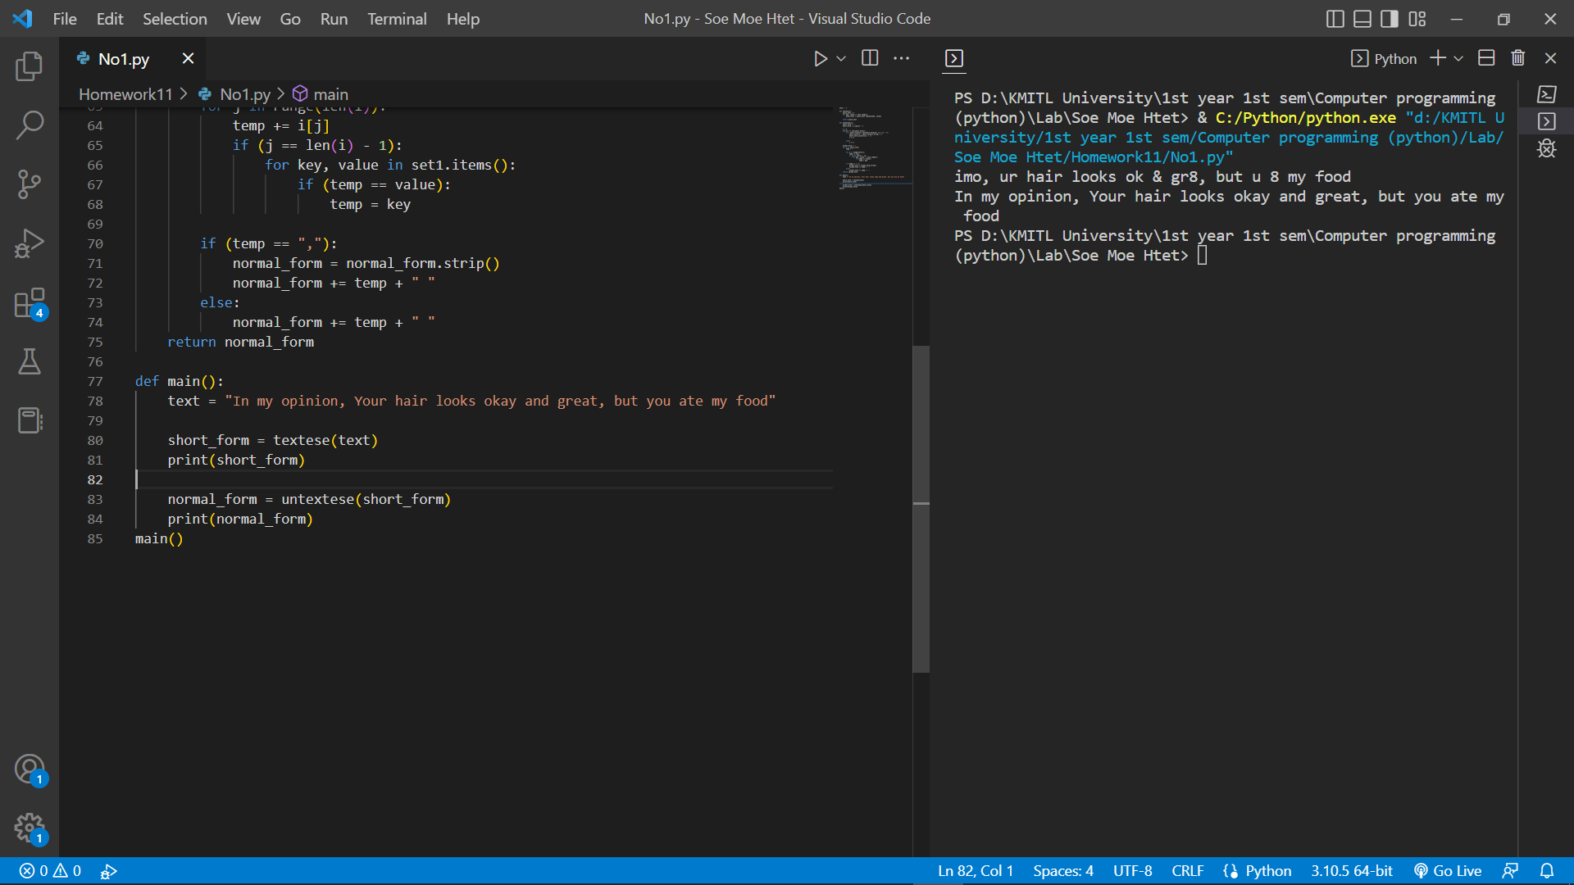

Code:

set1 =  {

                "be": "b",

                "because": "cuz",

                "see": "c",

                "the": "da",

                "okay": "ok",

                "are": "r",

                "you": "u",

                "without": "w/o",

                "why": "y",

                "see you": "cu",

                "ate": "8",

                "great": "gr8",

                "mate": "m8",

                "wait": "w8",

                "later": "!8r",

                "tomorrow": "tmr",

                "for": "4",

                "before": "b4",

                "once": "1ce",

                "and": "&",

                "Your": "ur",

                "You're": "ur",

                "As far as I know": "afaik",

                "As soon as possible": "asap",

                "At the moment": "atm",

                "Be right back": "brb",

                "By the way": "btw",

                "For your information": "FYI",

                "In my humble opinion": "imho",

                "In my opinion": "imo",

                "Laughing out loud": "lol",

                "Oh my god": "omg",

                "Rolling on the floor laughing": "rofl",

                "Talking to you later": "ttyl",

            }

def textese(s):

    plain_text = s

    for key, value in set1.items():

        plain_text = plain_text.replace(key, value)

    return plain_text

def untextese(s):

    short_form = ""

    short_form = s.split(" ")

    i = 0

    while(i != len(short_form)):

        if ( short_form[i][ len(short_form[i]) -1 ] == ","):

            short_form[i] = short_form[i].strip(",")

            short_form.insert(i+1, ",")

            i += 2

        else:

            i += 1

    normal_form = ""

    for i in short_form:

        temp = ""

        for j in range(len(i)):

            temp += i[j]

            if (j == len(i) - 1):

                for key, value in set1.items():

                    if (temp == value):

                        temp = key

        if (temp == ","):

            normal_form = normal_form.strip()

            normal_form += temp + " "

        else:

            normal_form += temp + " "

    return normal_form

def main():

    text = "In my opinion, Your hair looks okay and great, but you ate my food"

    short_form = textese(text)

    print(short_form)

    normal_form = untextese(short_form)

    print(normal_form)

main()

No.2

Result:

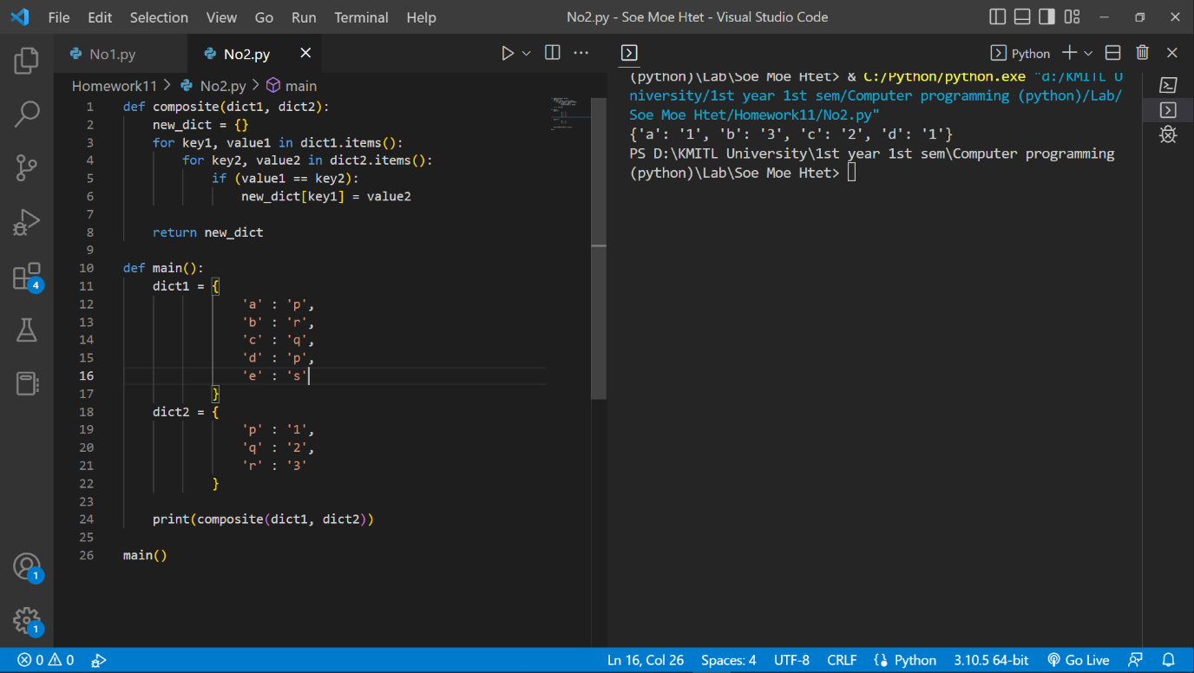

Code:

def composite(dict1, dict2):

    new_dict = {}

    for key1, value1 in dict1.items():

        for key2, value2 in dict2.items():

            if (value1 == key2):

                new_dict[key1] = value2

    return new_dict

def main():

    dict1 = {

                'a' : 'p',

                'b' : 'r',

                'c' : 'q',

                'd' : 'p',

                'e' : 's'

            }

    dict2 = {

                'p' : '1',

                'q' : '2',

                'r' : '3'

            }

    print(composite(dict1, dict2))

main()

No.3

Result:

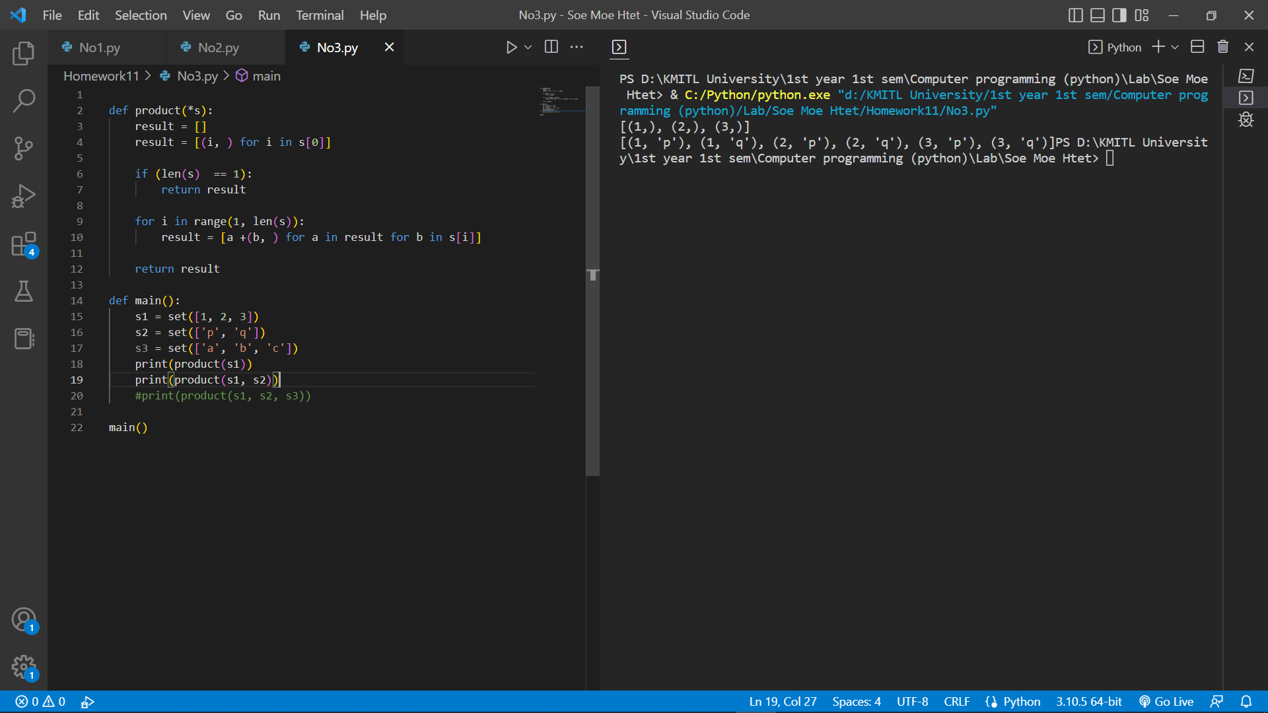

Code:

def product(*s):

    result = []

    result = [(i, ) for i in s[0]]

    if (len(s)  == 1):

        return result

    for i in range(1, len(s)):

        result = [a +(b, ) for a in result for b in s[i]]

    return result

def main():

    s1 = set([1, 2, 3])

    s2 = set(['p', 'q'])

    s3 = set(['a', 'b', 'c'])

    print(product(s1))

    print(product(s1, s2))

    #print(product(s1, s2, s3))

main()